Exercise 2

Regular Grammar & Regular Sets

Q 1: Construct the Non Deterministic Finite automata for the following regular expressions.

1. (a+b+c)\*
2. (ab+bc)d
3. (ab+bc)\*k\*(d+e)
4. a+bb+cc

Q 2: Let M1 and M2 be two finite automata accepting the language L1 and L2 respectively as shown in following figure. Construct the finite automata to accept the language.

1. L1 U L2
2. L1 ꓵ L2
3. L1 – L2
4. L2 – L1



Q 3: For the finite automaton given in the following figure, find the corresponding regular expression.

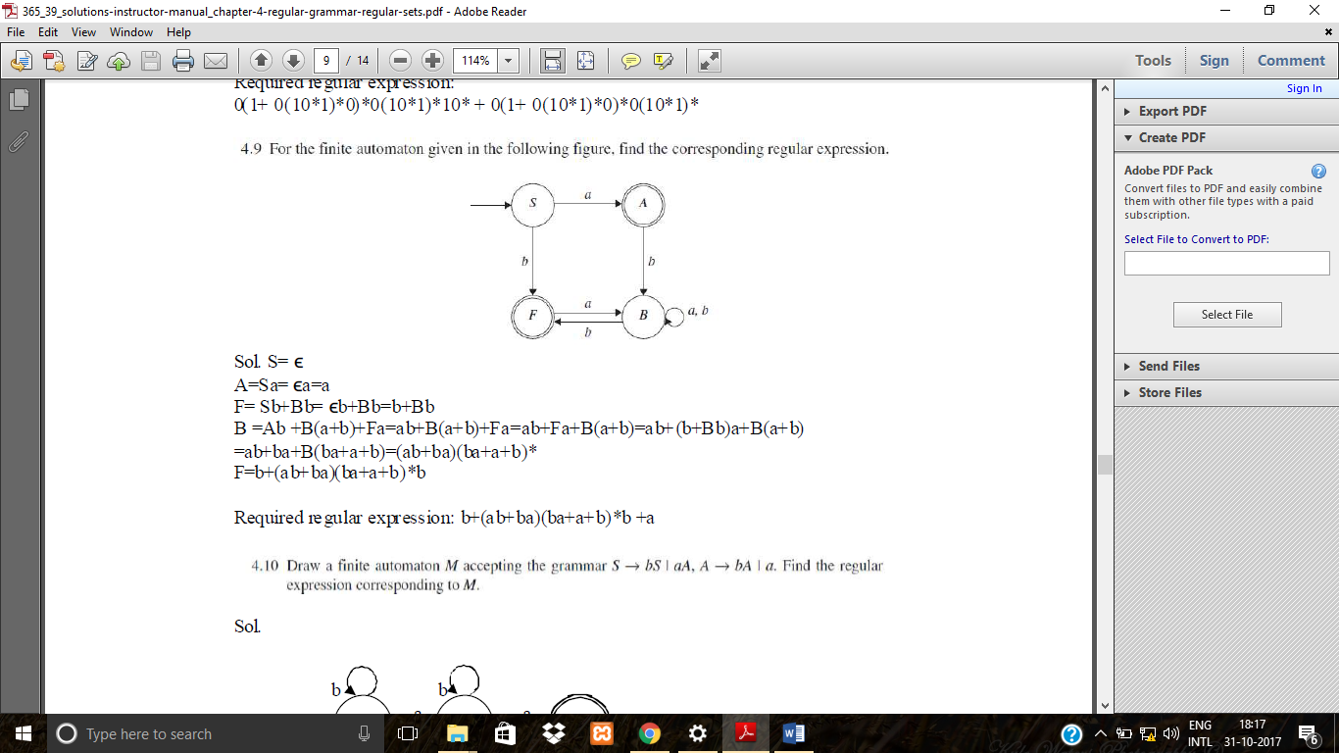

Q 4: Design a finite automaton for the regular expression 10+(0+11)0\*1. If it is an NFA, then convert it into its equivalent DFA.

Q 5: For the finite automaton in the following figure find the corresponding regular expression.



Q 6: For the following regular expressions, draw an ϵ-NFA and convert them into their equivalent DFA.

1. (a+b)\*(abb+ababab)(a+b)\*
2. (a+b)(ba)\*(abb)\*